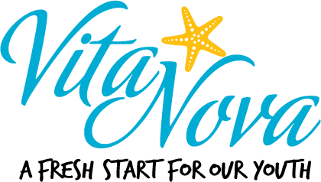

Board of Directors
(Revised Oct. 20, 2019)

Mr. Frank Gulisano,
Chairman
(Term: August 2013 – Jan 2020, Final 3-year term)
Summit Reality Inc.
1701 N Federal Hwy # 4, Boca Raton, FL 33432
o: (561) 395-1216
e: fgulisano@summitrealtyfl.com

Mr. Anthony Marino
Treasurer
(Term: Dec 2016 – Jan 2020, First 3-year term)
Anthony Marino CPA
o: 561-686-2799
e: AMarinojrCPA@gmail.com

Mr. Michael Bayer
Board Governance Chair
(Term July 2015 – Jan 2021, Final 3-year term)
Curren, Bayer & Associates.
o: 561-371-0126
e: MTBayer@aol.com

Mr. Alexandre M. Santos
Wealth Management, (Term Jan 2014 – Jan 2020, Final 3-year term)
UBS, Boca Raton
o: 561-670-8977
e: AlexSantos@mindspring.com

Mr. Scott Murray
Governance Co-Chair Member, Secretary
(Term Jan 2017 – Jan 2020, First 3-year term)
Murray & Guari Trail Attorneys
1525 N Flagler Dr #100, West Palm Beach, FL 33401
o: 561-366-9099
e: SMurray@murrayguari.com

Ms. Judy Ramella
(Term June 2017 – Jan 2020, First 3-year Term)
2016 President Realtors Association of the Palm Beaches
c. (561)-596-0940
email. jramellarealtor@bellsouth.net

Mr. David Scott
Member, (Term May 2018 – Jan 2021, First 3-year term)
City of Boynton Beach
Director of Economic Development and Strategy
o. (305) 771-5212
c. 1-410-598-2321
email. descott@kaizenmanagementsolutions.com

Mr. Dominick Macri
Member, (Term April 2019 - Dec 2022, First Term)
Wealth Planner - U.S. Bank Private Wealth Management
o. 561.653.3354
c. 561.225.4492
domenick.macri@usbank.com

Mrs. Kristy Pressly
Member, (Term June 2019 - Dec 2022, First Term)
Corporate Attorney – The Breakers Palm Beach
o. 561.655-6611
c. 561.373-2815
Kristy.Pressly@thebreakers.com

Mr. Brad Jankowski
Member, (Term October 2019 – Dec 2022, First Term)
Attorney – Haile, Shaw & Puffenberger
o. 561-627-8100
bjankowski@haileshaw.com

Michael Branch
Member, (Term October 2019 – Dec 2022, First Term)
CEO – Morse Life
o. (561) 570-2820

