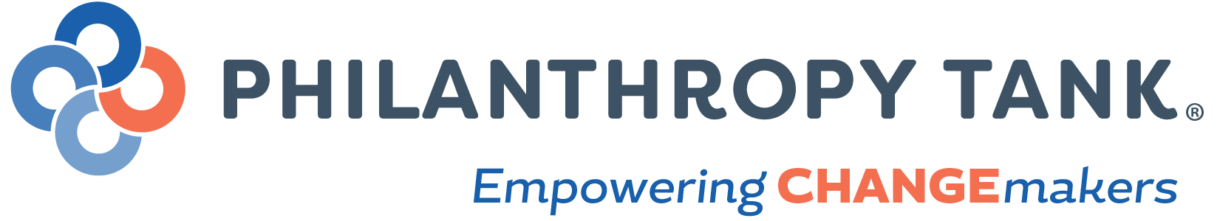

Philanthropy Tank
Board of Directors

President
Evan C. Deoul, CAP
Bernstein Global Wealth Management
Palm Beach Gardens
561-820-2140
Kravis Center Investment Committee, Jewish Federation of PBC

Past President – Treasurer
Michael L. Kohner, CPA, AEP, CFP, CAP
HBK CPAs and Consultants
Wellington
Education Foundation of PBC, Economic Council
561-469-5492, ext. 3210

Secretary
William Meyer
Meyer Jabara Hotels
Palm Beach
Community Philanthropist
561-273-4625

Director
Karen Conway
Right to Play
Park City, Utah
Community Foundation of Park City
435-729-9189

Director
Vicki Pugh
Advancement Experts
William T. Dwyer High School Foundation, Holy Spirit Lutheran Church Fdn
Jupiter
561-212-3637

Palm Beach County Leadership Council Term: September 1, 2020 - August 31, 2023

Andrew Aliminana Merrill Lynch
Debra Elmore A.K. Consulting
Andrew Huber Bank of America
Michele Jacobs Economic Council of Palm Beach County
Randy Scheid Quantum Foundation
Tom Vining Otis Americas, Retired CEO

